Team 3 – DESKIFY
Shwetha B – DEVOPS

Resources used:
Web app
Azure SQL
CI/CD in devops
Kubernetes (Working on it)

Deploying MVC application in webapp using CI/CD

Azure web app to deploy API
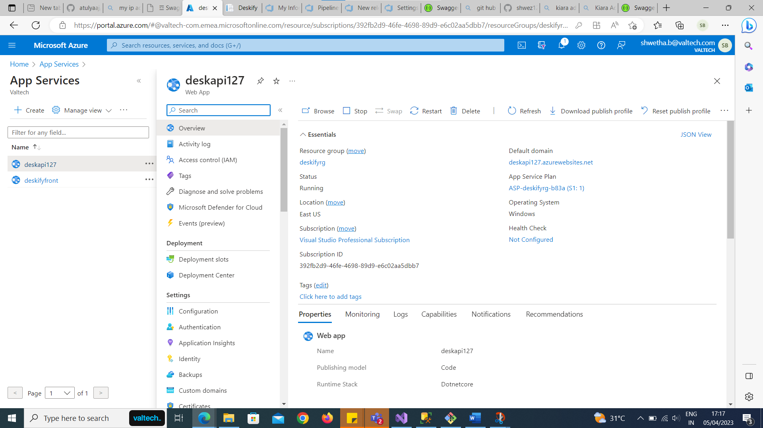

Created Azure SQL and Allowed public internet IP addresses to access the resource
And Migrated local database to azure database
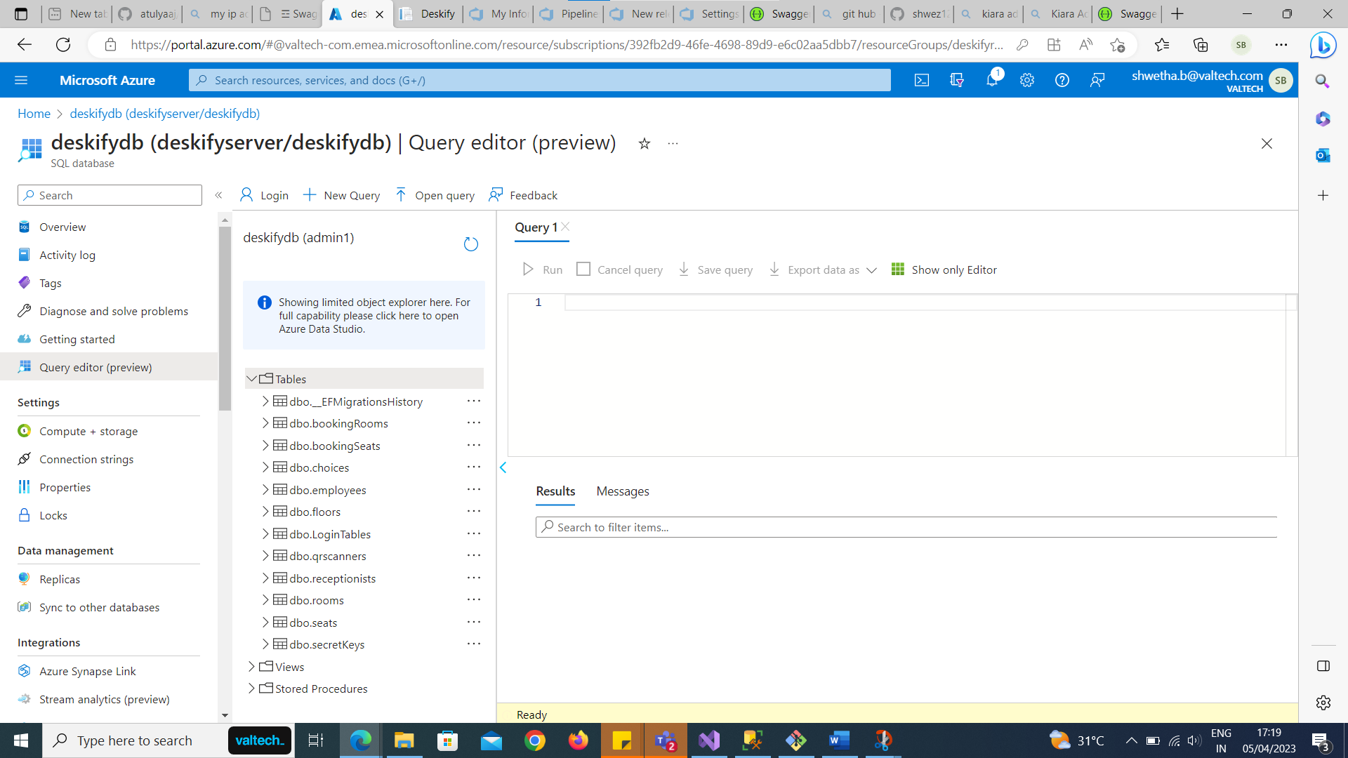

Publishing API with azure database to Web app1

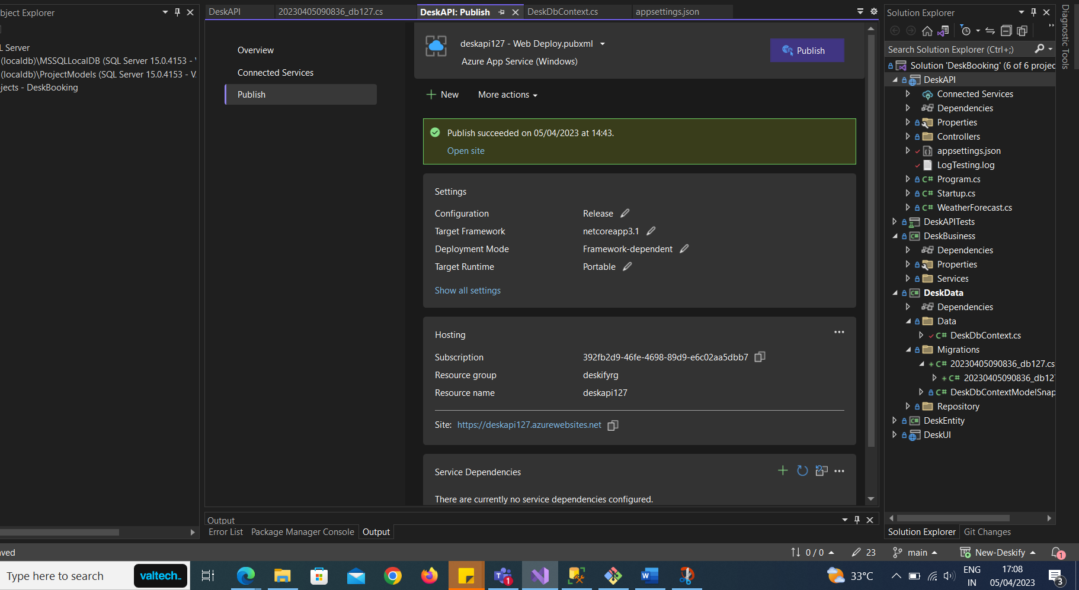

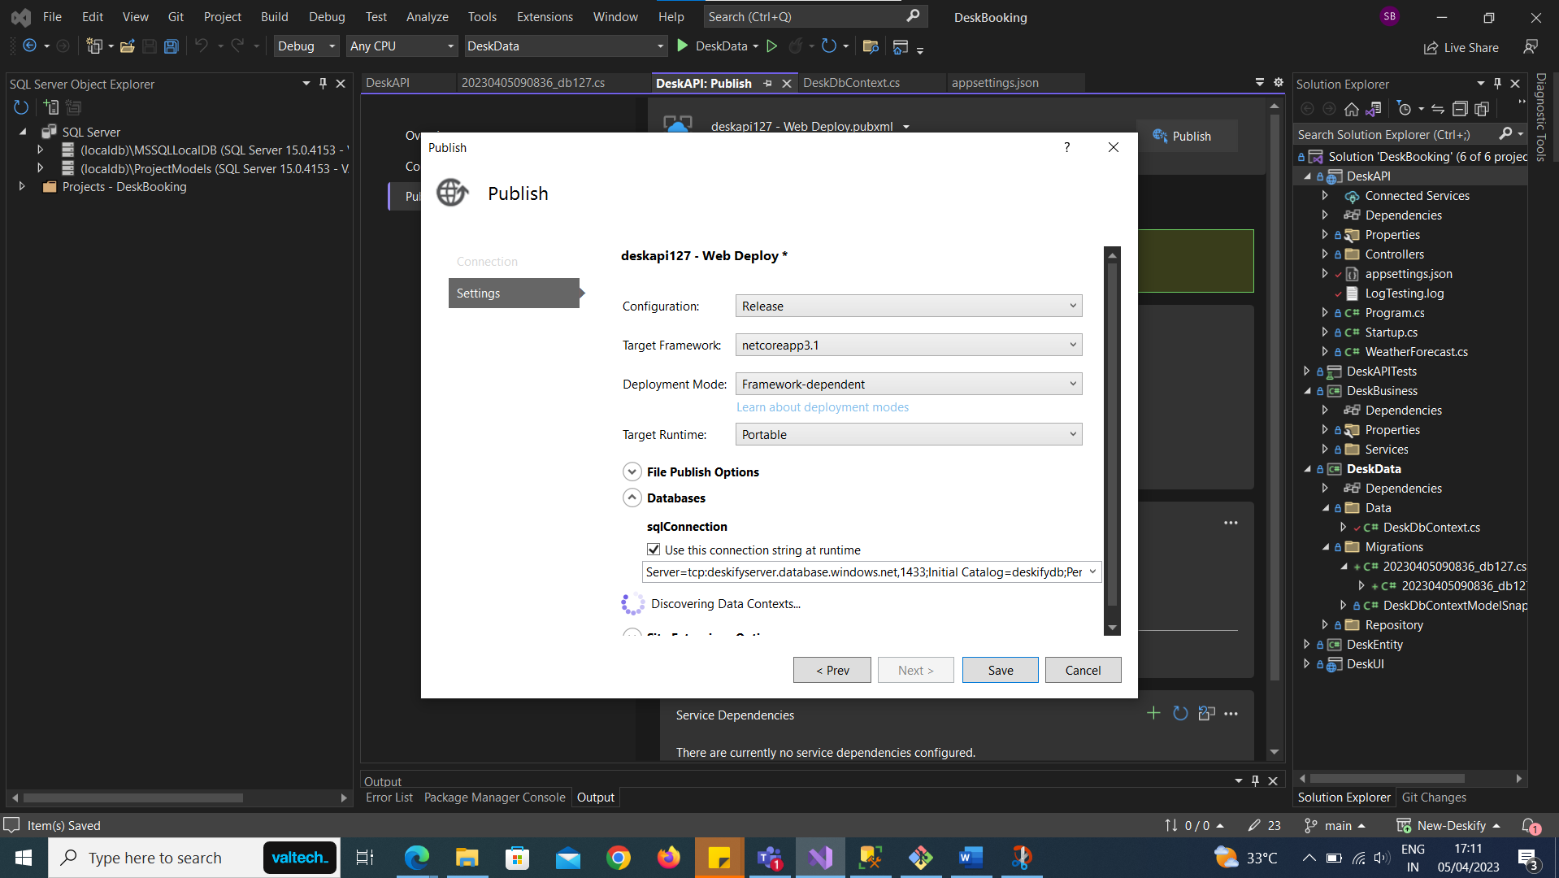

Successful Publish of API
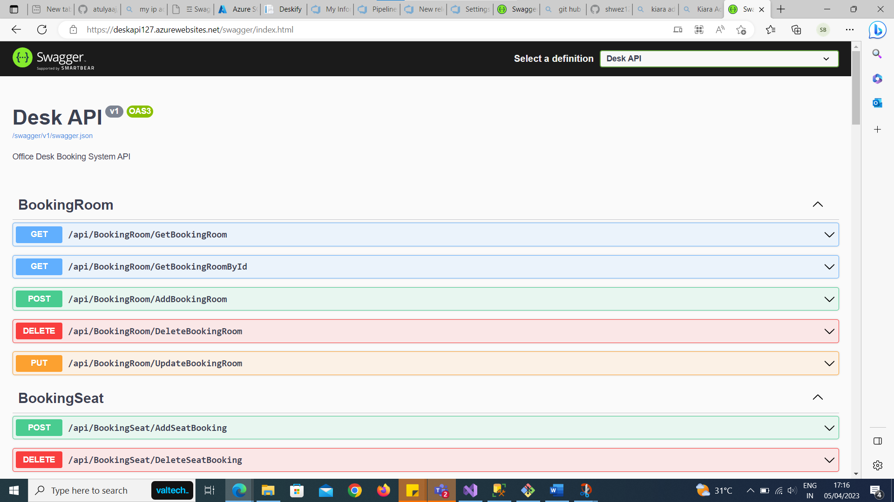

Created Web app to deploy MVC application using CI/CD
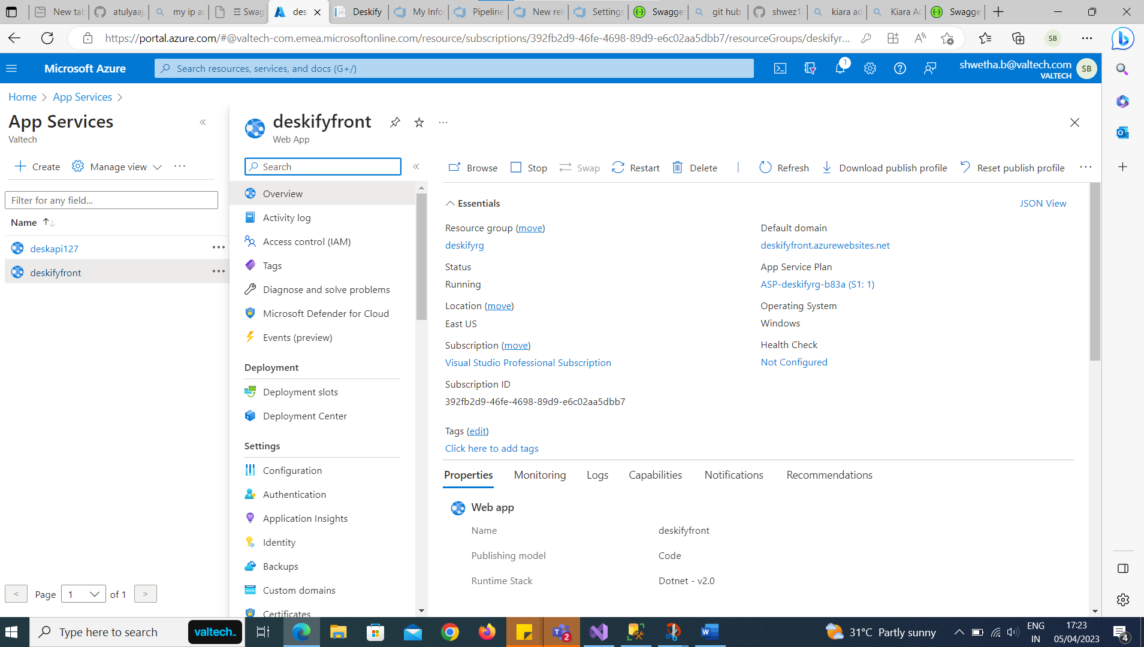

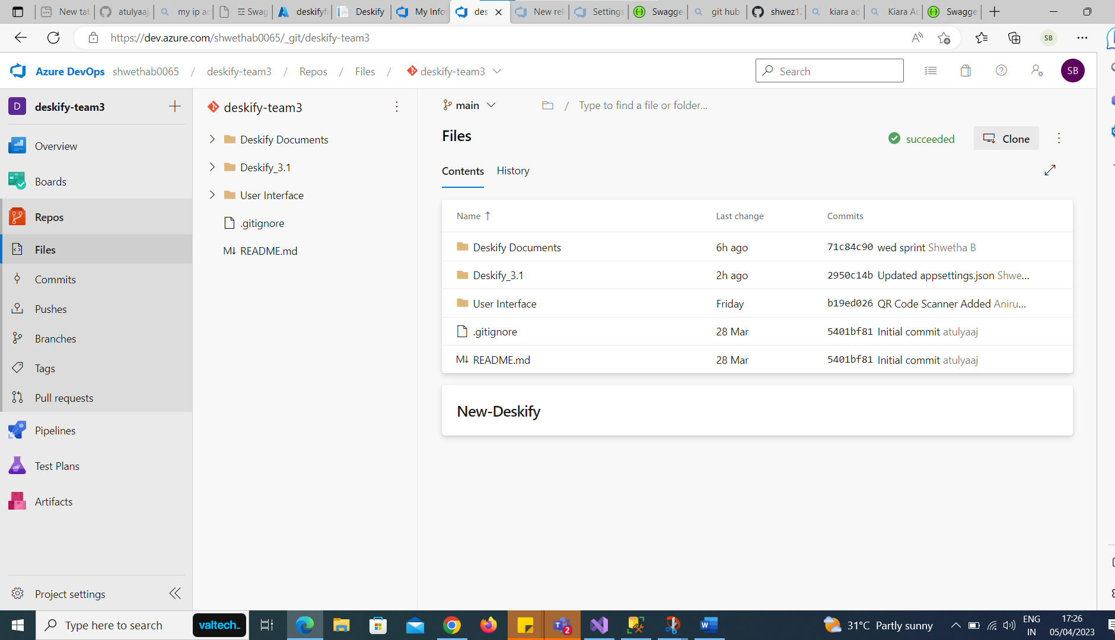

Establishing connection between API and Frontend by adding API Webapp URL link
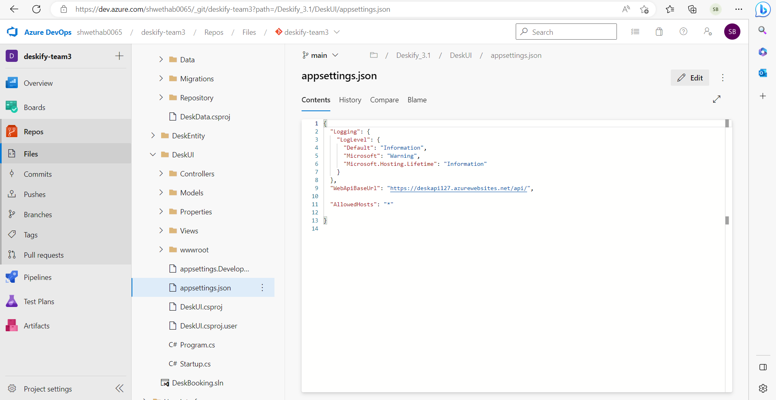

Build Pipeline
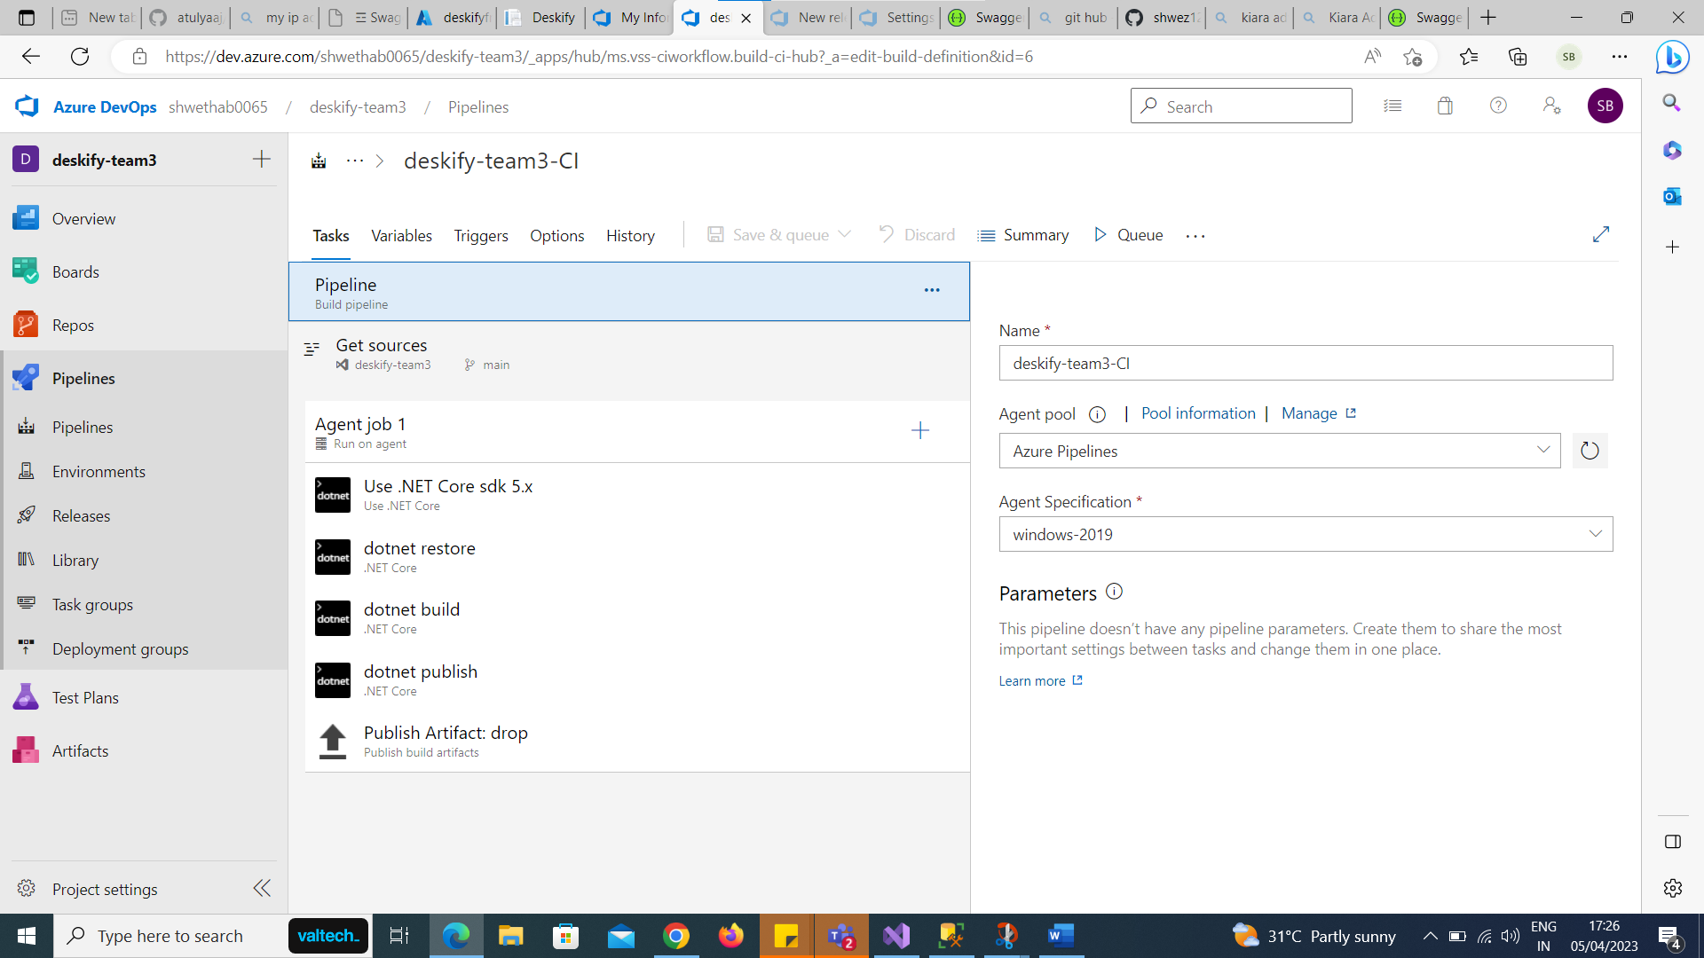
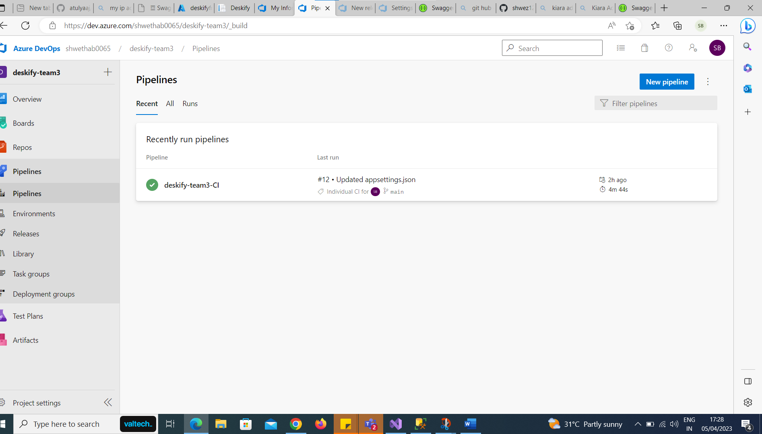

Establishing Service Connection
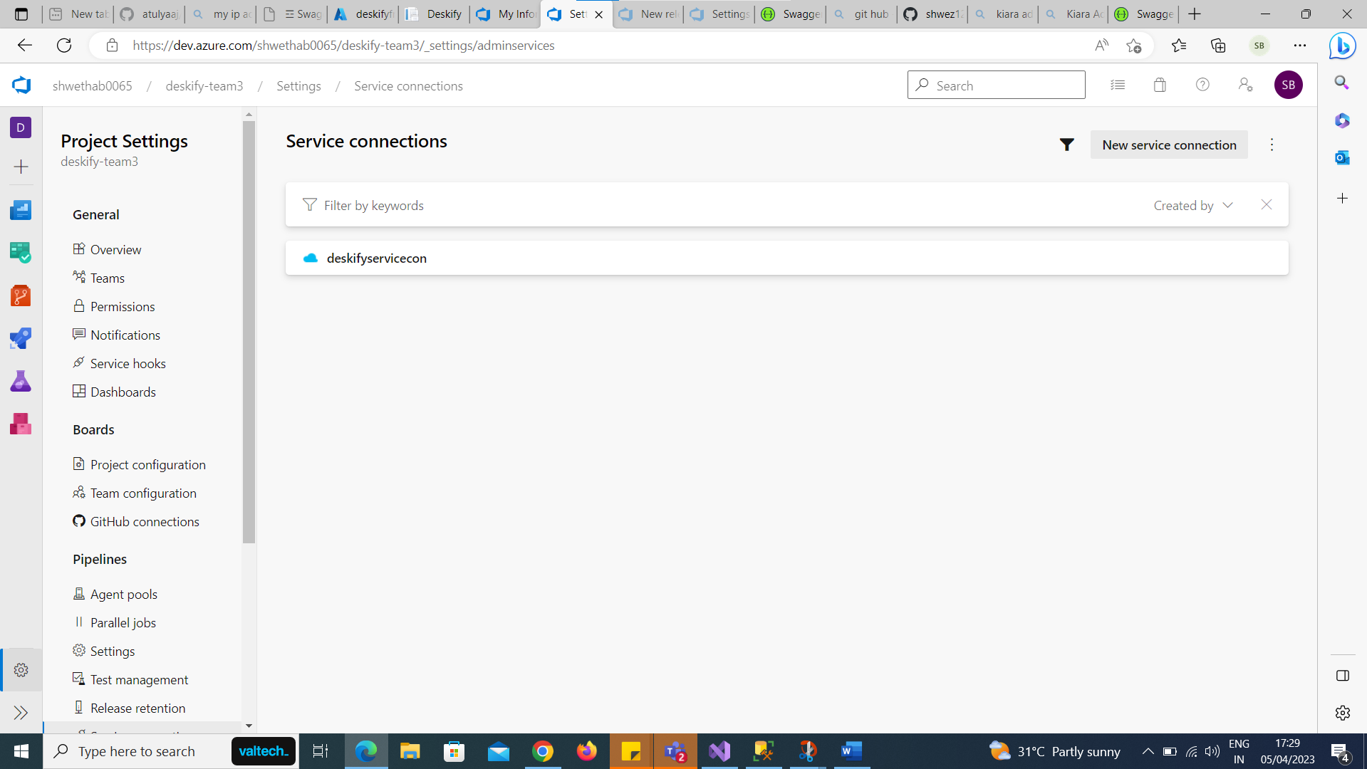

Release Pipeline
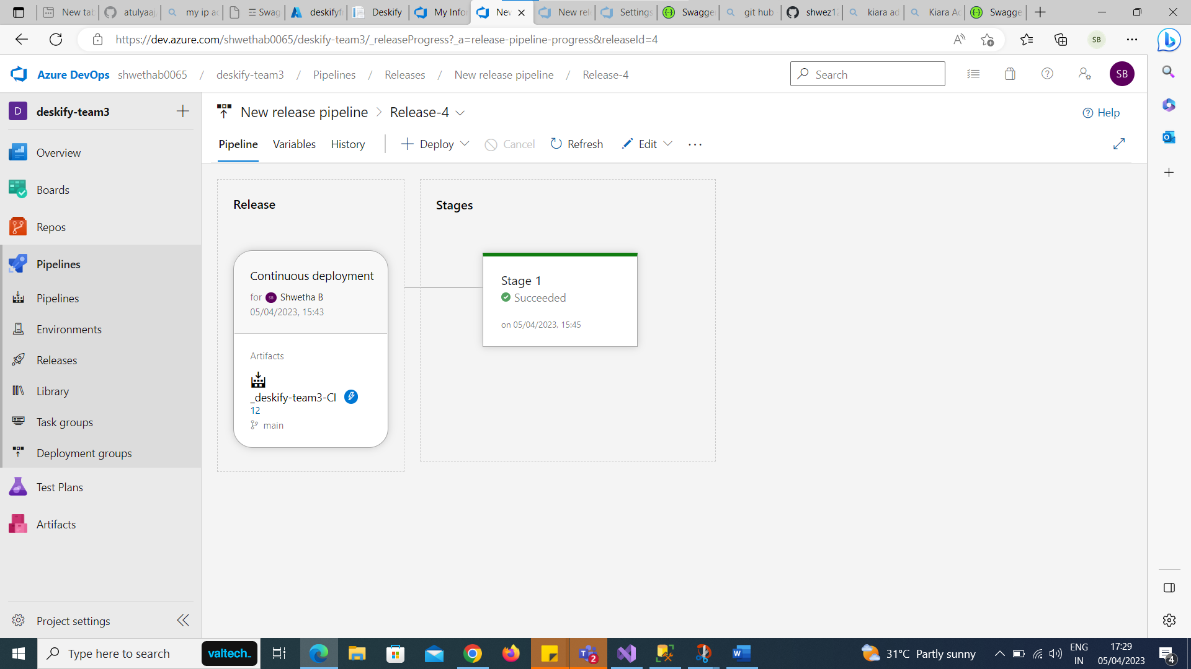

OUTPUT :
URL : deskifyfront.azurewebsites.net

